BIGANTR: A model for bedrock-incising, gravel-abrading, near-threshold rivers

Vanessa Gabel\*

Gregory E. Tucker

Benjamin Campforts

\*vanessa.gabel@colorado.edu

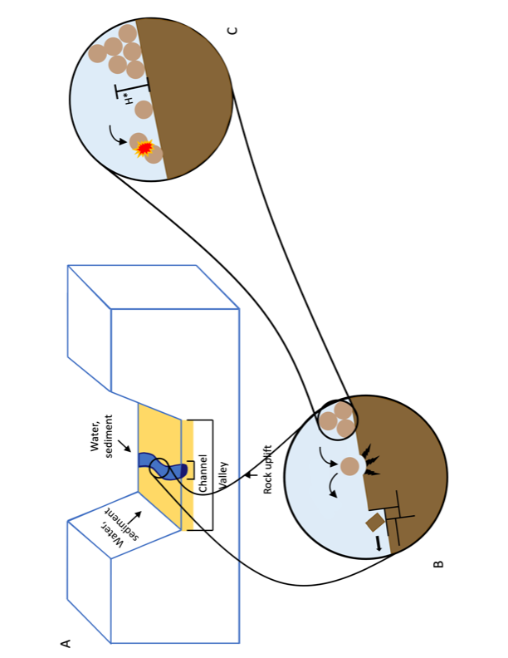

We present a model for river profile evolution that incorporates bedrock erosion via plucking and abrasion, sediment transport, and bedload loss via grain attrition. We find that we can capture alluvial channel morphologies within a model framework that also incises bedrock. We also find grain attrition to be a fundamental ingredient in creating concave-up steady state river profiles.